



TRAIT OF THE MONTH:

Self-Awareness

An awareness of one's own character,

feelings, motives, and desires.

**Why is self-awareness important?**

Self awareness is important because when we have a better understanding of ourselves, we are able to experience ourselves as unique and separate individuals. We are then empowered to make changes and to build on our areas of strength as well as identify areas where we would like to make improvements.

*.*



***Knights Cards***

In order to reinforce good behavior at RMCA we are always on the lookout for students who are exhibiting good character. Teachers and staff will be awarding *KNIGHTS* cards to students who demonstrate the KNIGHTS qualities.

Each card will be recorded and can be redeemed monthly for a lunch treat and slide ride.

­­



October: **K**indness

November: **N**obility

December**: I**nitiative

January: **G**enerosity

February: **H**onesty

March**: T**rustworthy

April**: S**elf-awareness

May**:**  Review

Last Months Elementary Trustworthy Class Projects

A big congradualtions to Mrs. Hill’s third grade class for winning the trustworthy class project pizza party. Her class wrote and performed poems and raps on trustworthiness.

**We had 122 KNIGHTS cards winners for the month of March.**

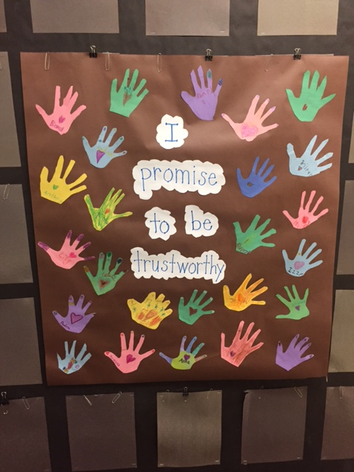

.



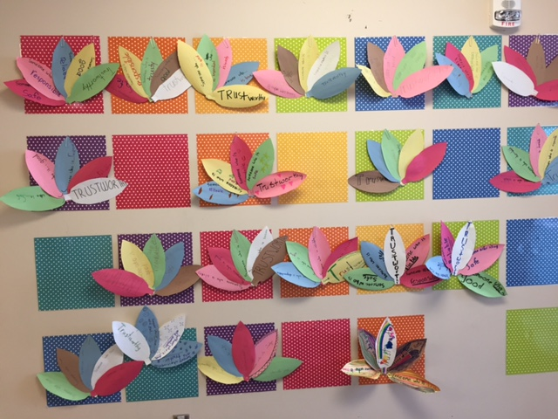

**KNIGHTED Ceremony**

We would like to invite you to come to our KNIGHTED ceremony on May 12th in the RMCA commons from 6 to 7:30 PM. Those children that earned 5 or more knights cards will get an award and those kids that earned one of character trait to spell out the word KNIGHTS will be KNIGHTED. Look out for your child’s invitation at the end of the month.

**Watch DOGS Doughnuts for Dads event We** would like to invite the male role models to come grab a doughnut and juice when you drop off your kids on April 29th 7 to 8 AM as a thank you to all the male role models that have come in to volunteer for the Watch D.O.G.S  program  and to encourage more participation in the Watch D.O.G program.

*Please check out Ms. Albers new website at* [*www.danaalbers.weebly.org*](http://www.danaalbers.weebly.org)

|  |  |
| --- | --- |
|  |  |
|  |  |
|  |  |  |
|  |  |
|  |  |
|  |  |
|  |  |
|  |  |
|  |  |
|  |  |
|  |  |
|  |  |  |

**Helpful links & information:**

**\*Act for Youth Center for Excellence**

Social and emotional learning nurtures self-awareness, the ability to identify our own feelings, as well as how our feelings and thoughts influence what we do. Below you'll find a link to resources to help promote self-awareness.

<http://www.actforyouth.net/youth_development/professionals/sel/self-awareness.cfm>

**\* 5 Ways to Help Teens Build Self-Awareness**

<https://lifesmartblog.com/2014/05/02/5-ways-to-help-teens-build-self-awareness/>

**\* VIA Institute on Character**

The VIA Survey of Character Strengths is a simple self-assessment that takes less than 15 minutes and provides a wealth of information to help you understand your core characteristics.

https://www.viacharacter.org/www/

**How to Develop Self-Awareness in Teens**

**Helpful Tips:**

Your actions can help your teen develop the kind of self-awareness he needs to succeed in life. Your teen needs to have self-awareness to help her understand her personality, her beliefs and her values. Self-awareness makes it possible for her to make decisions, plan for her future and decipher her emotions. While it’s something she develops throughout her life, self-awareness becomes even more important during the teenage years when she is maturing and learning to become independent. When she’s self-aware, she is more likely to make positive choices.

**Step 1**

Be a realistic role model when it comes to self-awareness, advises the Ask Dr. Sears website. For example, when it comes to your teen’s self-esteem, you need to model it yourself. When you exhibit positive self-esteem in front of your kids, they learn to exhibit the same behavior. Show your kids that you are confident in your abilities by saying you’re always up for a new challenge rather than you’re not sure you can do something because you’ve never done it. Try new things with enthusiasm, and point out that while you are not perfect at everything, you’re really good at a lot of things. This helps your teen learn that self-awareness is important and that without self-confidence, self-awareness is difficult to come by.

**Step 2**

Teach your teens to focus on their values, advises the Wright State University College of Business. For example, ask your teen to make a list of values that are important to her, such as being a good friend, or focusing on her grades. Talk to her about focusing on those values each day, by practicing them as often as possible. This will help her develop the self-awareness to live virtuously without falling by the wayside.

**Step 3**

Help your teen handle his stress and understand where it comes from, advises Wright State University. His self-awareness will grow when he learns to recognize the signs of stress in his life and what causes the stress. You can have him make a quick note anytime he feels particularly stressed. That note can include what he was doing, where he was, who he was with and what he thinks caused him to feel stressed, such as his friends being late for planned events and causing him to be late as well. When he is able to recognize what stresses him out, he can use his self-awareness to prevent future stress and manage his day-to-day life with ease.

**Step 4**

Stop using labels to describe your teen, advises the Ask Dr. Sears website. Labels make your child feel as though she is destined to become what it is you say about her, and it can alter her self-awareness with negativity. For example, even if you lovingly label her as shy, she may begin to believe she is shy and it could prevent her from coming out of her shell as she attempts to live up to the label you unintentionally gave her. Forget the labels and just love your teen

Adapted from an article on *LivingStrong.com* written by  Tiffany Raiford



**Teacher Appreciation**

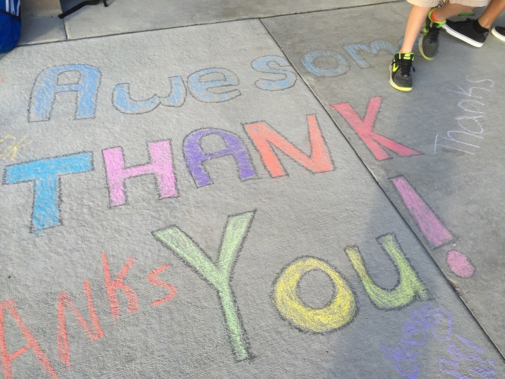 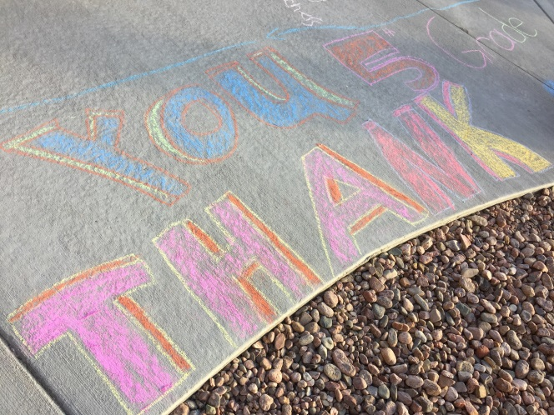



***Check this out! :)***

Students at RMCA shared their appreciation of all the hard work the teachers and staff do for them by writing out personal thank you cards and decorating the teacher entrance.